1. **Answer the following questions about DNA.**

a) Label the image using the words in the box below.

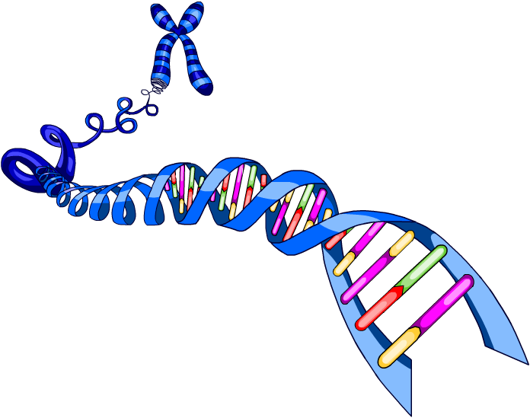

………………............

………………............

………………..............

………………............

DNA double helix chromosome base pairs gene

b) Fill in the missing words in the text using the words in the box below.

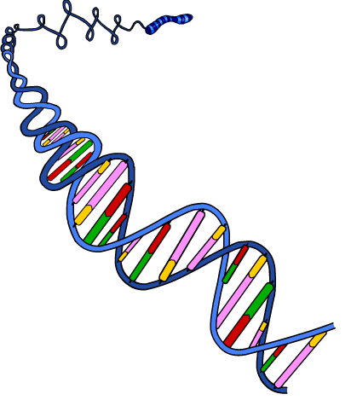

double helix bases genetic code DNA

gene base pairs cell activity

Chromosomes are found in the nucleus of cells and are made up of long molecules of tightly coiled …………………**.** These molecules carry coded information that controls ………………… and the characteristics of the organism. A ………………… is a small section of a DNA molecule. DNA has a ………………… structure that is formed by two strands that are coiled together. These strands of the DNA molecule are linked by ………………… which are held together by weak hydrogen bonds. The four bases of DNA are adenine (A), thymine (T), cytosine (C) and guanine (G). These ………………… always pair up in the same way – A with T, and C with G. The sequence of these bases along a DNA molecule is what forms the …………………**.**