1. **What is a clone?**

…………………………………………………………………………………………………………

…………………………………………………………………………………………………………

1. **Plant clones may be produced by cuttings or tissue culture. Fill in the table with some advantages and disadvantages of each method.**

|  |  |  |
| --- | --- | --- |
|  | **advantages** | **disadvantages** |
| **cuttings** |  |  |
| **tissue culture** |  |  |

1. **Two methods of cloning animals are embryo transplant and adult cell cloning. Fill in the table with true or false to compare the differences and similarities of these methods.**

|  |  |  |
| --- | --- | --- |
|  | **embryo transplant** | **adult cell cloning** |
| Fertilization takes place. |  |  |
| An embryo is separated into individual cells. |  |  |
| A nucleus is removed from an unfertilized egg and replaced with that from an adult cell. |  |  |
| Host mothers are often used. |  |  |
| Each embryo cell goes on to form a new embryo. |  |  |
| Offspring are produced which are clones of each other. |  |  |
| Embryo cells are clones of the parent. |  |  |
| New offspring form with the best characteristics of both parents. |  |  |
| Fertility drugs are usually used. |  |  |

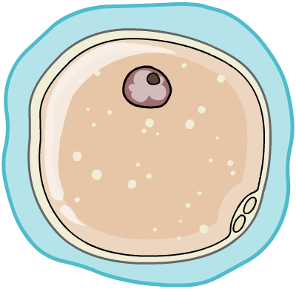

1. **Therapeutic cloning can be used to cure certain diseases. Arrange these statements into the correct order.**

|  |  |
| --- | --- |
| **event** | **order** |
| The embryo will die. |  |
| The embryo cell is allowed to divide. |  |
| The nucleus of an embryo cell is replaced with DNA from the patient. |  |
| The stem cells can be used to treat the patient. |  |
| Over five days, the dividing embryo will produce stem cells with the same genes as the patient. |  |
| The stem cells are removed. |  |

1. **Some people believe that therapeutic cloning is an important medical development, but others feel that it is wrong. What do you think and why?**

…………………………………………………………………………………………………………

…………………………………………………………………………………………………………

…………………………………………………………………………………………………………

…………………………………………………………………………………………………………

…………………………………………………………………………………………………………

…………………………………………………………………………………………………………

…………………………………………………………………………………………………………  
…………………………………………………………………………………………………………

…………………………………………………………………………………………………………