Blood Pressure Worksheet
This worksheet accompanies Blood Pressure.ppt

1. Why does blood have to leave the heart at high pressure?
……………………………………………………………………………………………………………
……………………………………………………………………………………………………………
2.
c | z | s | v | u | r | w | b | o | b | h | h | y | m | e
c | i | s | q | z | d | e | w | p | e | n | p | z | u | m
h | w | l | l | t | g | c | l | a | a | b | f | q | m | w
z | t | c | o | n | w | g | m | h | t | d | a | o | s | c
g | w | i | d | t | m | p | s | k | s | l | f | n | e | h
s | r | l | b | y | s | g | w | b | p | m | i | y | k | w
w | s | o | g | d | y | a | k | p | e | w | p | z | n | j
l | r | t | d | y | u | p | i | r | r | s | h | z | t | h
t | d | s | v | m | f | a | c | d | m | t | i | y | b | e
u | v | y | x | g | z | u | x | x | i | p | u | l | s | e
x | g | s | v | e | r | x | x | d | n | q | q | s | f | k
u | f | v | j | y | q | r | w | h | u | c | y | g | s | n
w | c | m | l | r | h | j | q | u | t | b | x | n | w | b
q | p | a | l | o | r | e | t | s | e | l | o | h | c | k
j | m | l | g | x | v | y | n | x | p | g | s | c | x | c
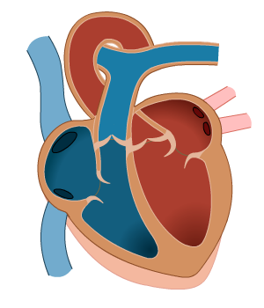
Clues
- Blood pressure during a heart beat.
- Blood pressure between heart beats.
- The unit of blood pressure.
- What is measured to find heart rate.
- The units of pulse.
- A type of lipid that can block arteries.
g. A solid that sticks to the inside of the arteries
3. Annie is a teenager. She went to her doctor and had her blood pressure taken.
She was told that her blood pressure was 110/60. What does this mean?

…………………………………………………………………………………………………………
…………………………………………………………………………………………………………
4. List four lifestyle choices you can make that will increase your blood pressure, and two that will decrease it.

Increases blood pressure Decreases blood pressure

………………………………………..….…… .………….…………………………………………
………………………………………..….…... .………….…………………………………………
………………………………………..….……
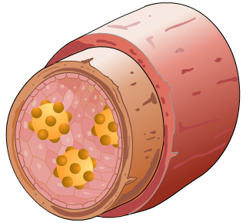
………………………………………..….……

- Put the following sentences in order to explain how
plaque is made and the effect it has on blood pressure.
Write a number in the box to the right of each
sentence to show the order of the sentences.

order
Blood pressure increases.
The plaque builds up on the artery walls.
Cholesterol moves around the body in the blood vessels.
The amount of space left for the blood to flow through is reduced.
Sometimes the cholesterol sticks to one part of the artery, forming plaque.

