**1. Explain what asexual reproduction is, using a spider plant as an example.**

……………………………………………………………………………………………………………………….………………………………………………………………………………………………..……………………………………………………………………………………………………………………………………………………………………………………………………………………………………………………………………………………………………………………………

**2. Name two other organisms that reproduce asexually.**

……………………………………………………………………………………………………………………………………………………………………………………………………………………

**3. Complete the following sentences using the words in the box below.**

a) In **…………………** reproduction, the cells of the offspring are produced by

**…………………** from the parentcells. This means the **………………..** in these cells are

identical to the parent plant.

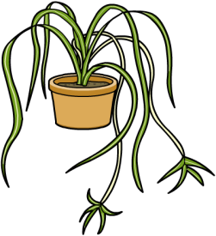 b) The new organism is a **………………..** of the original.

asexual mitosis alleles parent clone osmosis

1. **Describe how to clone a spider plant using the process of tissue culture.**

…………………………………………………………………………………………………………………………………………………………………………………………………………………………………………………………………………………………………………………………………………………………………………………………………………………………………………

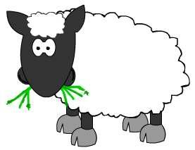

1. 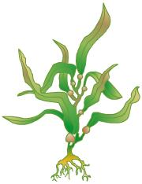**Why is cloning a plant easier than cloning an animal? Use the following terms in your answer: stem cells, specific cells, differentiation.**

…………………………………………………………………………………………………….…..……………………………………………………………………………………………………………………………………………………………………………………………………………………………

…………………………………………………………………………………………

1. **Human clones are commonplace in our society.**

**a) What are they more commonly called?**

………………………………………………………………………………………………………

**b) Describe the natural process that creates a human clone.**

………………………………………………………………………………………………….…………………………………………………………………………………………………..……

**c) Give two reasons why many people believe that artificial human cloning is not ethically acceptable.**

.……………………………………………………………………………….………….…………..……………………………………………………………………………………………………………………………………………………………………………………………………………………………………………………………………………………………………………………………………………………………………………………………………………………………

**7. Dolly the sheep, born in 1996, was the first mammal to be cloned from an adult cell.**

**a) Give one disadvantage or risk of cloning an animal.**

………………………………………………………………………………………………………………………………………………………………………………………………………………

**b) List two ways in which cloning an animal could be advantageous to humans.**

………………………………………………………………………………………………………………………………………………………………………………………………………………………………………………………………………………………………………………………

1. **Explain the process of nuclear transfer that was used to produce Dolly. Include the following terms: nucleus, egg cell, enucleated, division, electric current, udder cell, DNA, surrogate, embryo.**

……………………………………………………………………………………………………………………………………………………………………………………………………………………………………………………………………………………………………………………………………………………………………………………………………………………………………………………………………………………………………………………………………………………………………………………………………………………………………………………………………………………………………………………………………………………………………………………………………………………………………………………………………………………………………………………………………………………………………………………………………………………………………………………………………………………………………………………………………………………………………………………………………………………

1. **Explain why the DNA could not be taken from a sperm or egg cell for the above process.**

………………………………………………………………………………………………………………………………………………………………………………………………………………………………………………………………………………………………………………………………

1. **Describe a possible complication of using genetically modified pigs to supply**

**humans with replacement organs.**

………………………………………………………………….……………………………………..……………………………………………………………………………………………………..…….…………………………………………………………………………….………………………….…….