Adaptation Worksheet
This worksheet accompanies the presentation Adaptation.ppt

Scientists can study the adaptations shown by extinct animals to find out more about the conditions and habitats in which they lived. Look at the images and descriptions below and answer the accompanying questions.
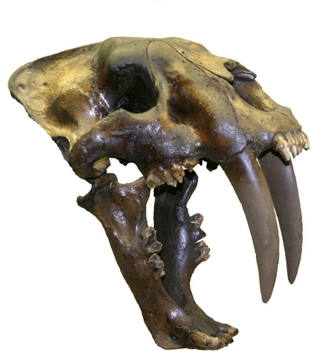

1. This photo shows the skull of a sabre-toothed cat.
How was it well adapted for life as a predator?

……………………………………………………………………………………………………………....................…………………………………………………………………………………………………………………………………………………………………………………………………………………………………………………………………………………………………………………

2. This picture shows Hallucigenia, an organism which lived 500 million years ago.
It used tentacles on one side for walking.

What adaptations can you see that Hallucigenia might have used to repel predators?
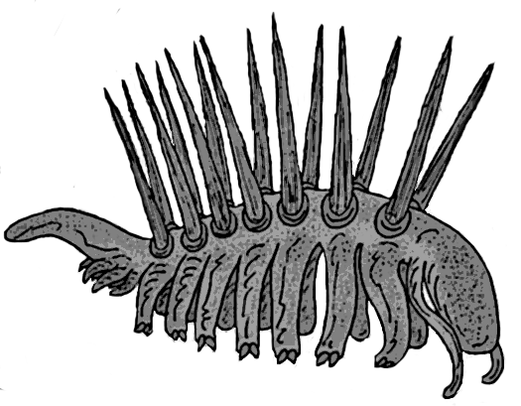
……………………………………………………………………………………………………
……………………………………………………………………………………………………
……………………………………………………………………………………………………

3. The woolly mammoth was a mammal that became extinct approximately ten thousand
years ago. This image shows what the mammoth is thought to have looked like.

What conditions do you think the mammoth lived in? Why do you think this?

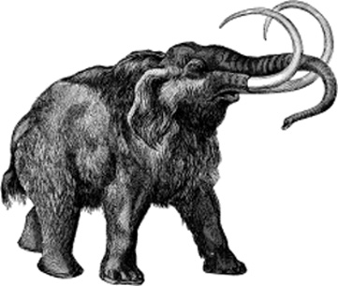
…………………………………………………………………………………………………………………………………………………………………………………………………………………………………………………………………………………………………………………………………………………………………………………………………………………………………………………………………………………………………………………………………………………………………………………………………………………………………………………………………………………………

Image credits:
sabre tooth tiger © 2012 mikeledray, Shutterstock.com
Hallucigenia © Stanton F. Fink. This image is reproduced under the terms of the GNU Free Documentation License. A copy of the license can be read at this address: http://commons.wikimedia.org/wiki/Commons:GNU_Free_Documentation_License
Woolly mammoth © NPS. This image is released into the public domain.

