Worksheet One
This worksheet accompanies slide 3 of Reading Literature 1.ppt

The Gingerbread Man

How well do you know the story of the Gingerbread Man? Look at the pictures below and practice retelling the story in your own words.

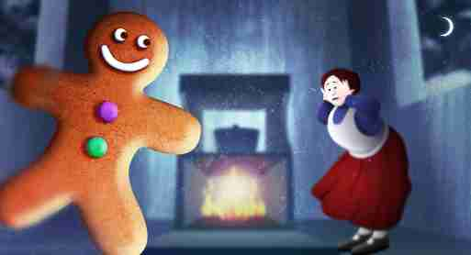



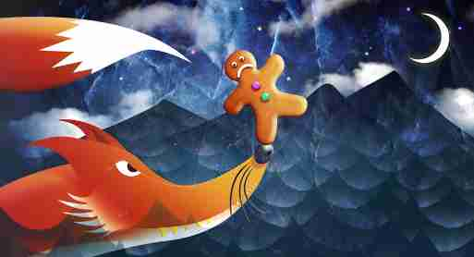

Worksheet Two
This worksheet accompanies slide 4 of Reading Literature 1.ppt

Tell the story

Cut out these boxes and rearrange them to tell the story about the Gingerbread Man.

The Gingerbread Man comes to life and runs away.

The fox offers to carry the Gingerbread Man over the river.

An old woman makes a gingerbread man.

The fox eats the Gingerbread Man.

The Gingerbread Man meets a fox by the river.

Worksheet Three
This worksheet accompanies slide 4 of Reading Literature 1.ppt

Tell the story

Draw the main events of the Gingerbread Man’s story in the order that they happened in the boxes below.

`
1.
2.

3.
4.

Worksheet Four
This worksheet accompanies slide 5 of Reading Literature 1.ppt

Asking questions
Fill in the table with information about the Gingerbread Man’s story.

Story feature | Answer
Who is the main character?
Who are the other characters?
Where does the story begin?
Where does the story end?
What big mistake does the Gingerbread Man make?
What is the story’s moral (lesson)?

Worksheet Five
This worksheet accompanies slide 6 of Reading Literature 1.ppt

Thinking about words
Read the text below about a train station. Circle words that describe the sounds of the train station. Underline words that describe how busy the train station is. Below, copy down all the words that you do not know and try to figure out what they mean by talking about them with your class or looking them up.

Speakers blared. Rushing trolleys clashed and clattered. Pigeons flapped. The train growled impatiently, ready to leave.
Jo and Ahmed skidded along the platform, diving in and out of the busy crowds. They quickly shoved past a pile of suitcases, just in time to see the train doors hiss shut.
“Mind the gap!” roared a voice as the train slammed out of the station.

Circle words that describe the sound of the train station.

Underline words that describe the busyness of the train station.

Words you don’t understand:
________________________ ________________________
________________________ ________________________
________________________ ________________________
________________________ ________________________
________________________ ________________________

