Worksheet Fourteen
This worksheet accompanies slide 3 of Macbeth Act 3 Part 1.ppt

Banquo
Complete this mind map to show everything you have learned about Banquo and then answer the questions on the next page.

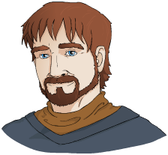

Now answer these questions about Banquo.

- What does Banquo ‘fear’ at this point?

___________________________________________________________________________________________________________________________________________________________________________________________________

- What are our impressions so far about the character of Banquo?

___________________________________________________________________________________________________________________________________________________________________________________________________

- How would you describe the relationship between Macbeth and Banquo?

___________________________________________________________________________________________________________________________________________________________________________________________________

- How does Banquo react to the witches’ prophecy about him?

___________________________________________________________________________________________________________________________________________________________________________________________________

5. How does this contrast with Macbeth’s reactions?

______________________________________________________________

___________________________________________________________

___________________________________________________________

Worksheet Fifteen
This worksheet accompanies slide 6 of Macbeth Act 3 Part 1.ppt

Soliloquy ordering exercise
When Macbeth thinks about the witches’ prophecy for Banquo, he fears that Banquo’s sons will take his crown. Macbeth’s soliloquy develops in intensity as he speaks, showing how his paranoia is growing. Sort these key lines from Macbeth’s soliloquy into the correct order. Write a number between one and seven in the boxes alongside each of these key lines.

Key line | Order
Upon my head they placed a fruitless crown

To make them kings, the seed of Banquo kings!

Our fears in Banquo / Stick deep

There is none but he / Whose being I do fear

They hail’d him father to a line of kings:

Put rancours in the vessel of my peace

For them the gracious Duncan have I murdered

Worksheet Sixteen
This worksheet accompanies slide 9 of Macbeth Act 3 Part 1.ppt

Lady Macbeth’s advice
How does Lady Macbeth counsel her husband at the beginning of Act Three?
Read each statement and decide whether it is true or false. Circle your answer in
the boxes next to each statement.

She asks him why he stays on his own. | T | F
She tells him that he should remember the murder  of Duncan. | T | F
She reassures him that what’s done is done. | T | F
She says that anything that can’t be fixed should be  left alone. | T | F
She asks him not to send his regards to Banquo. | T | F
She asks him to hide his emotions at the banquet tonight. | T | F
She says that combing his hair will make him appear  less suspicious. | T | F

Worksheet Seventeen
This worksheet accompanies slide 10 of Macbeth Act 3 Part 1.ppt

Power
How has the power shifted between Macbeth and Lady Macbeth? What is happening to their relationship? Draw bars on this graph to show who you think has the most power in each Act. Bars nearer to 0 show that Lady Macbeth has the most power, bars nearer to 10 show that Macbeth has the most power.

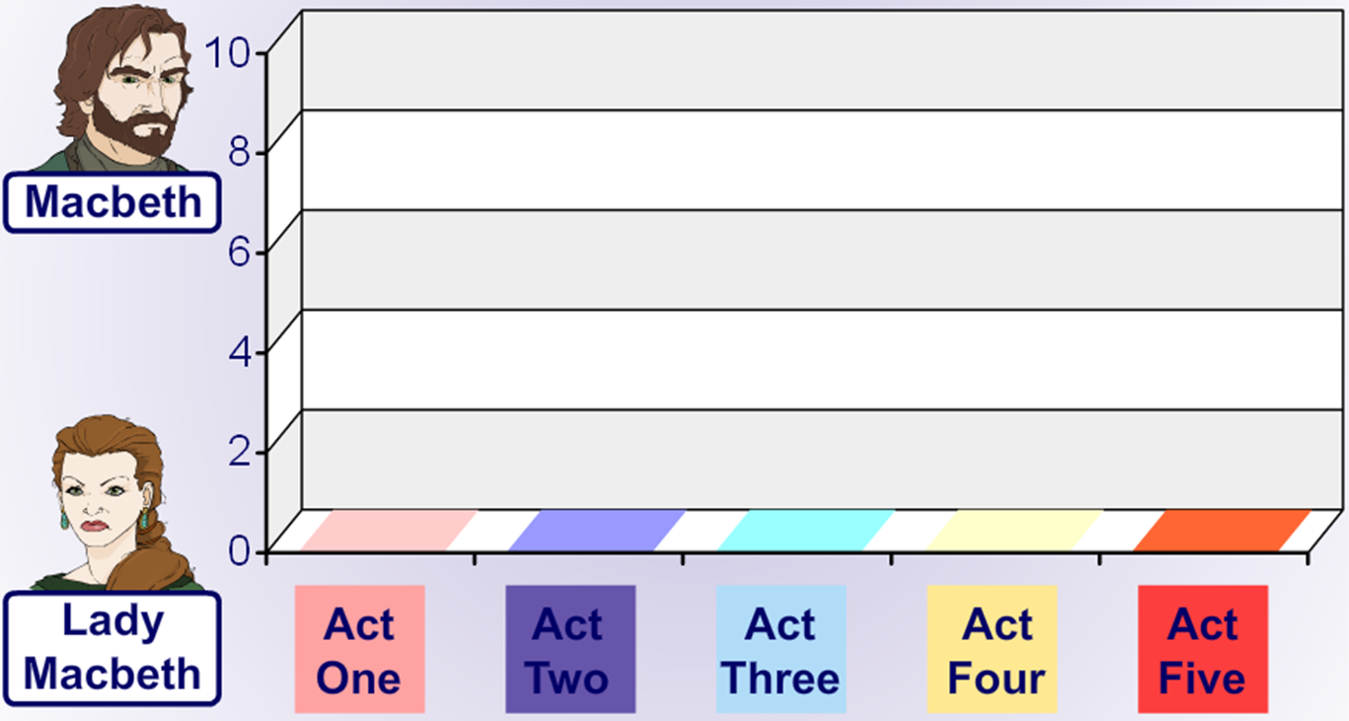
Worksheet Eighteen
This worksheet accompanies slide 12 of Macbeth Act 3 Part 1.ppt

Act Three, Scene Four, lines 49–59
What qualities does Lady Macbeth exhibit in this scene? Compare them to the qualities she exhibited in Act Two, Scene Two. Find a quotation to back up
each quality.

1.__________________________________________________________________
Quotation:______________________________________________________________________________________________________________________________

2.__________________________________________________________________
Quotation:______________________________________________________________________________________________________________________________

3.__________________________________________________________________
Quotation:______________________________________________________________________________________________________________________________

4.__________________________________________________________________
Quotation:______________________________________________________________________________________________________________________________

5.__________________________________________________________________
Quotation:___________________________________________________________________________________________________________________________
Worksheet Nineteen
This worksheet accompanies slide 7 of Macbeth Act 3 Part 2.ppt

Dramatizing the banquet scene
Consider the dramatization of at least one other stage or film production of
this scene.

How effective do you think your chosen dramatization is?
____________________________________________________________________________________________________________________________________________________________________________________________________________________________________________________________________________

What aspects of blocking, lighting, staging, sets and props are most successful? Least successful?
____________________________________________________________________________________________________________________________________________________________________________________________________________________________________________________________________________

How has the director developed the characterization of the protagonists at this point?
____________________________________________________________________________________________________________________________________________________________________________________________________________________________________________________________________________
Worksheet Twenty
This worksheet accompanies slide 8 of Macbeth Act 3 Part 2.ppt

Getting in character
What do you think each of the main characters is thinking at the end of Act Three? Remember to consider what they have seen and done in the previous Acts, as well. Write a short summary of the thoughts of each of the following characters. Find a quotation to support each of your summaries.
Macbeth
Lady Macbeth

Ross
Lennox

Worksheet Twenty-one
This worksheet accompanies slide 9 of Macbeth Act 3 Part 2.ppt

Act Three summary
How much can you remember about the plot so far? Try to fill in the blanks in this summary of Act Three. A list of potential words is given below.

_______ becomes _________ of the good fortune that Macbeth has had but he keeps his suspicions to himself. Macbeth meets him and invites him to the_______. He is very insistent that he_______. However, after this encounter Macbeth begins to worry about the witches’ prophecy that the _____ of Banquo will be kings.

Macbeth plots to _____ Banquo and meets with some hired murderers. In the meantime Lady Macbeth tries to _______ her husband as she is concerned that he will not behave well at their banquet that evening. He does not tell her of his plan to kill Banquo.

At the ________ Macbeth receives news from the murderers that Banquo has been killed, but he is distressed to hear that Banquo’s son ________ has escaped. As ________ goes to take his seat at the banquet he sees that Banquo’s ghost has taken his place. Lady Macbeth is forced to think on her feet and explain away Macbeth’s outburst. In the end she has to ask the other guests to_____.

After the banquet _______ and another Lord discuss the tyrannical way in which Macbeth is ruling the country. _______ voices his suspicions about the deaths of Duncan and Banquo. They also say that ________ has gone to _______ to get help.
Fleance banquet Lennox kill England
sons attend banquet Macbeth leave
Macduff counsel Lennox Banquo suspicious

