Worksheet Five
This worksheet accompanies slide 5 of Macbeth Act 2 Part 1.ppt
Boardworks Shakespeare: Macbeth Act Two

Is this a dagger?
Reread Macbeth’s “Is this a dagger” speech in Act Two, Scene One. Then have a look at the excerpts below and write the modern-day translations next to each one.

Come, let me clutch thee: ____________________________________________________________________
There’s no such thing. / It is the bloody business which informs / Thus to mine eyes: ________________________________________________________________________________________________________________________________________
Or art thou but / A dagger of the mind: ____________________________________________________________________
I have thee not and yet I see thee still! ____________________________________________________________________
I see thee still; / And, on thy blade and dudgeon, gouts of blood: ________________________________________________________________________________________________________________________________________
Mine eyes are made the fools o’the other senses: ____________________________________________________________________
Nature seems dead: _________________________________________________________
Thou marshall’st me the way that I was going: _________________________________________________________

Worksheet Six
This worksheet accompanies slide 6 of Macbeth Act 2 Part 1.ppt
Boardworks Shakespeare: Macbeth Act Two

Reactions

Shakespeare devotes all of Act Two, Scenes Two and Three to Macbeth and Lady Macbeth’s responses to their crime and the reactions of the other characters to the murder of Duncan. Answer the following questions to record the responses of Macbeth and Lady Macbeth in Act Two, Scene Two.

1. Look carefully at different ways in which Macbeth and Lady Macbeth respond to their crime. Are there any hints in their reactions about what might develop in the rest of the play?

____________________________________________________________________________________________________________________________________________________________________________________________________________________________________________________________________________

2. In Act Two, Scene Three, how do they behave once Duncan’s murder has been discovered by Macduff?

____________________________________________________________________________________________________________________________________________________________________________________________________________________________________________________________________________

3. At the end of Scene Three, Duncan’s sons, Malcolm and Donalbain, decide to flee Scotland, as they fear they will be blamed for their father’s murder. Why is it important for the plot that they leave at this point?
_______________________________________________________________________________________________________________________________________________________________________________________________________

_____________________________________________________________

Worksheet Seven
This worksheet accompanies slide 9 of Macbeth Act 2 Part 1.ppt
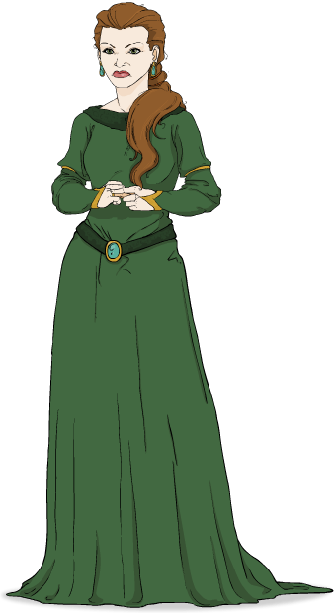
Boardworks Shakespeare: Macbeth Act Two
Act Two, Scene Two, lines 32–48
List five qualities that Lady Macbeth exhibits in lines 32–48.
Give quotations to back up your points.

Quality | Evidence

Worksheet Eight
This worksheet accompanies slide 3 of Macbeth Act 2 Part 2.ppt
Boardworks Shakespeare: Macbeth Act Two
Omens and portents
What omens and portents can you find in the whole play? Fill in the table below to chart what you find.

Act, scene and line reference | Omen/portent | Quotation
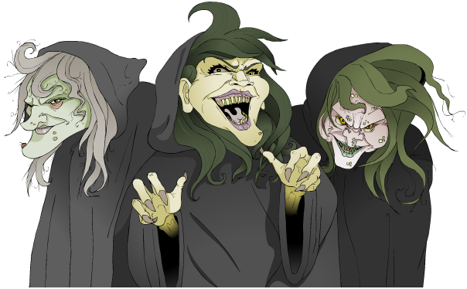
Worksheet Nine
This worksheet accompanies slide 5 of Macbeth Act 2 Part 2.ppt
Boardworks Shakespeare: Macbeth Act Two
Headline techniques
Think of at least one headline that contains an example of the following
linguistic techniques:

Emotive language
Alliteration
Pun/word play
Factual approach
Question


Worksheet Ten
This worksheet accompanies slide 6 of Macbeth Act 2 Part 2.ppt
Boardworks Shakespeare: Macbeth Act Two

Macbeth at the end of Act Two
Macbeth has now committed three murders: those of King Duncan and two guards, who are blamed for their master’s murder. Think carefully about the development of Macbeth’s character during the first two acts of the play. Answer the following questions to record your thoughts.

- What different aspects of Macbeth’s character have we seen up to this point?
____________________________________________________________________________________________________________________________________________________________________________________________________________________________________________________________

- Are there any hints in his behavior about how his character might develop in the rest of the play?
____________________________________________________________________________________________________________________________________________________________________________________________________________________________________________________________

- What are your thoughts and feelings about Macbeth at this point in the play?
___________________________________________________________________________________________________________________________________________________________________________________________
__________________________________________________________

Worksheet Eleven
This worksheet accompanies slide 7 of Macbeth Act 2 Part 2.ppt
Boardworks Shakespeare: Macbeth Act Two
Lady Macbeth at the end of Act Two
Lady Macbeth finally experiences the pride and joy of watching her husband be crowned king of Scotland at Scone. Her wishes have come true, and she is queen! Think carefully about the development of Lady Macbeth’s character during the first two acts of the play. Answer the following questions to record your thoughts.

- What different aspects of Lady Macbeth’s character have we seen up to
this point?
____________________________________________________________________________________________________________________________________________________________________________________________________________________________________________________________

- Are there any hints in her behavior about how her character might develop in the rest of the play?
____________________________________________________________________________________________________________________________________________________________________________________________________________________________________________________________

- What are your thoughts and feelings about Lady Macbeth at this point in
the play?
______________________________________________________________
___________________________________________________________
________________________________________________________
________________________________________________________

Worksheet Twelve
This worksheet accompanies slide 9 of Macbeth Act 2 Part 2.ppt
Boardworks Shakespeare: Macbeth Act Two

A changing relationship
The relationship between Macbeth and his wife is complex, and Shakespeare has allowed the audience to see into the very heart of their marriage. By the end of Act Two it looks to the audience as though they have achieved all that they set out to do. Complete the following activities in order to record your thoughts on their relationship at the end of Act Two.

1. Choose ten adjectives to describe the relationship between Macbeth and
Lady Macbeth.

2. Select a quotation to illustrate and support each of the adjectives you
have chosen. Do not forget to cite the quotation.
Boardworks Shakespeare: Macbeth Act Two

Adjective | Quotation

3. Write down five negative and five positive comments about their relationship.
Boardworks Shakespeare: Macbeth Act Two
Negative comments
- ________________________________________________________________________________________________________________________
- ________________________________________________________________________________________________________________________
- ________________________________________________________________________________________________________________________
- ________________________________________________________________________________________________________________________
- ________________________________________________________________________________________________________________________

Positive comments
- ________________________________________________________________________________________________________________________
- ________________________________________________________________________________________________________________________
- ________________________________________________________________________________________________________________________
- ________________________________________________________________________________________________________________________
- _________________________________________________________
______________________________________________________

- Find quotations/evidence to support the negative and positive qualities you have selected. Do not forget to cite the quotations.
Boardworks Shakespeare: Macbeth Act Two

Positive comments | Quotation/Evidence
Negative comments | Quotation/Evidence

Worksheet Thirteen
This worksheet accompanies slide 10 of Macbeth Act 2 Part 2.ppt
Boardworks Shakespeare: Macbeth Act Two
Act Two summary
How much can you remember about the plot so far? Try to fill in the blanks in this summary of Act Two. A list of potential words is given below.

Macbeth meets ________ and they briefly discuss the witches’ prophecy. When Banquo leaves, Macbeth imagines seeing a _______ in front of him with the handle towards his hand. Macbeth and Lady Macbeth decide to go ahead with the plan to kill ________. While Lady Macbeth _________ Duncan’s men, Macbeth carries out the murder.

The murder is discovered when Macduff and Lennox come to see Duncan. _______ is shocked and demands for the bell to be rung to wake the household. Macbeth and Lady Macbeth feign _________ and pretend that they are also shocked. Macduff at first avoids telling ___________ what has happened and says “’Tis not for you to hear what I can speak.”

________ suggests that Duncan’s men are the murderers as they were found with the bloody weapons. Macbeth backs up this suspicion by saying that he killed the men in his “fury.” Duncan’s sons, Malcolm and Donalbain, decide to flee _________ to save themselves; Malcolm to England and Donalbain to ________.

Later, Ross and Macduff discuss the murder and _________ is convinced that Duncan’s men were the murderers. He says that the sovereignty will fall to Macbeth and that Macbeth has gone to _________ to be crowned.

Lennox innocence Banquo Ireland Fife guilt

Macduff Lady Macbeth drugs Scone Ross

Scotland Macduff dagger crown Duncan

