Worksheet Thirty-three
This worksheet accompanies slide 3 of OMAM_Section_5.ppt

Plot summary: section five

Complete the summary by filling in the blanks.

Lennie is in the barn, stroking the dead body of his puppy, which he has __________ killed. Curley's wife comes in. She __________ in him about her unhappy marriage and her __________of being an actress. She __________ him to stroke her hair, but when he becomes too heavy-handed she tells him to stop.

Lennie is __________. He holds on to Curley's wife. She screams and __________, and Lennie __________. He puts his hand over her mouth and nose and shakes her, __________ her neck. Then he realizes what he has done. Remembering George's instructions earlier in the __________, he runs off to hide in the brush by the river.

__________ comes into the barn and discovers the body. He calls _________, then the other men. They prepare to go after Lennie and __________ him. Carlson discovers that his __________ is missing, and assumes that __________ has taken it. Whit is sent into Soledad to fetch the __________ __________.

The younger men, including George, set out to find Lennie. Left alone to __________ over the body of Curley's wife, Candy lies down in the hay and covers his eyes with his arm.

struggles invites accidentally breaking pistol frightened watch week George deputy sheriff panics
Candy kill dream Lennie confides

Worksheet Thirty-four
This worksheet accompanies slide 4 of OMAM_Section_5.ppt

Vocabulary

Match the words with their meanings.

console
cautious
confide
earnest
writhe
bewildered
vicious
confused

extremely violent or cruel

to wriggle

to trust someone with a secret

careful; attentive to danger

serious and sincere

to comfort

Worksheet Thirty-five
This worksheet accompanies slide 5 of OMAM_Section_5.ppt

Curley’s wife: redeeming features?
The male characters are uniformly hostile toward Curley’s wife. However, this doesn’t mean that her portrayal in the novella is necessarily unsympathetic. Reread Curley’s wife’s conversation with Lennie, then find a quotation that suggests she…

…is interested in other people: ________________________________________________ ______________________________________________________________________________________________________________________________________________________

…engages with Lennie: _____________________________________________________ ______________________________________________________________________________________________________________________________________________________

...tries to comfort Lennie: ____________________________________________________ ______________________________________________________________________________________________________________________________________________________

…accepts Lennie as he is: ___________________________________________________ ______________________________________________________________________________________________________________________________________________________

…is the only character to be concerned about an animal’s death: _________________ _________________________________________________________________________________________________________________________________________________________________________________________________________________________________

Can you think of any other good points to her character? If so, note them here: ____________________________________________________________________________________________________________________________________________________________________________________________________________________________________________________________________________________________________________
___________________________________________________________________________
Worksheet Thirty-six
This worksheet accompanies slide 6 of OMAM_Section_5.ppt

Thinking about Curley’s wife
Mind-map everything you know about Curley’s wife.

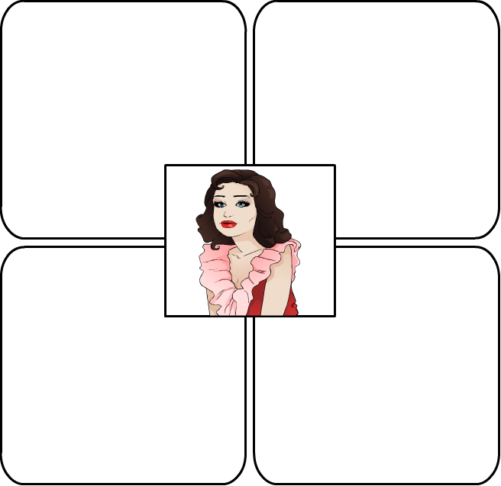

Worksheet Thirty-seven
This worksheet accompanies slide 12 of OMAM_Section_5.ppt

Dreams
Mind-map everything you know about dreams in Of Mice and Men.

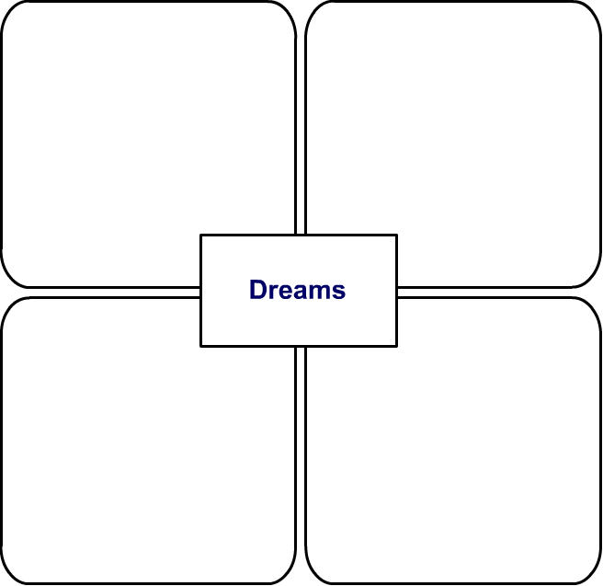
Worksheet Thirty-eight
This worksheet accompanies slide 12 of OMAM_Section_5.ppt

Loneliness
Mind-map everything you know about loneliness in Of Mice and Men.

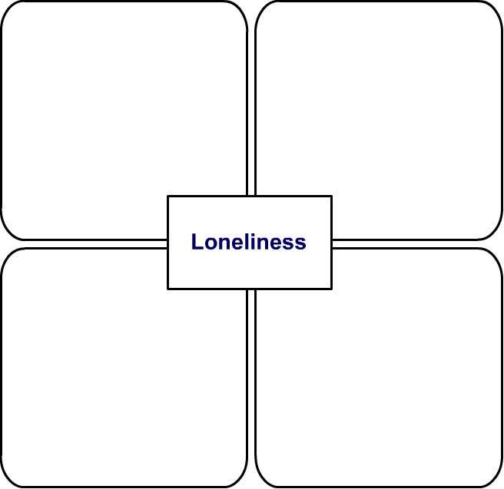

Worksheet Thirty-nine
This worksheet accompanies slide 14 of OMAM_Section_5.ppt

Stylistic techniques
Find an example from the fifth section of the novella of each of the following:

Alliteration: ________________________________________________________________
____________________________________________________________________________________________________________________________________________________________________________________________________________________________________________________________________________________________________________
___________________________________________________________________________

Simile: ____________________________________________________________________
____________________________________________________________________________________________________________________________________________________________________________________________________________________________________________________________________________________________________________
___________________________________________________________________________

Structure: __________________________________________________________________
____________________________________________________________________________________________________________________________________________________________________________________________________________________________________________________________________________________________________________
___________________________________________________________________________

A cinematic effect: __________________________________________________________
____________________________________________________________________________________________________________________________________________________________________________________________________________________________________________________________________________________________________________
___________________________________________________________
Worksheet Forty
This worksheet accompanies slide 15 of OMAM_Section_5.ppt

Hotseat

Answer from the perspective of each of the characters below.

How do you feel when you see the body of Curley’s wife?

Lennie: ____________________________________________________________________ ________________________________________________________________________________________________________________________________________________________________________________________________________________________________
Candy: ____________________________________________________________________ _________________________________________________________________________________________________________________________________________________________________________________________________________________________________
George: ___________________________________________________________________ ________________________________________________________________________________________________________________________________________________________________________________________________________________________________

Curley: ____________________________________________________________________
_________________________________________________________________________________________________________________________________________________________________________________________________________________________________

Slim: ______________________________________________________________________ _________________________________________________________________________________________________________________________________________________________________________________________________________________________________
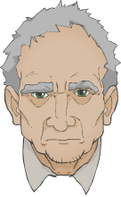





Worksheet Forty-one
This worksheet accompanies slide 15 of OMAM_Section_5.ppt

Hotseat

Answer from the perspective of each of the characters below.

How do you feel when everybody sets out to shoot Lennie?

Lennie: ____________________________________________________________________ ________________________________________________________________________________________________________________________________________________________________________________________________________________________________
Candy: ____________________________________________________________________ _________________________________________________________________________________________________________________________________________________________________________________________________________________________________
George: ___________________________________________________________________ ________________________________________________________________________________________________________________________________________________________________________________________________________________________________

Curley: ____________________________________________________________________
_________________________________________________________________________________________________________________________________________________________________________________________________________________________________

Slim: ______________________________________________________________________ _________________________________________________________________________________________________________________________________________________________________________________________________________________________________

Worksheet Forty-two
This worksheet accompanies slide 15 of OMAM_Section_5.ppt

Hotseat

Answer from the perspective of each of the characters below.

How do you feel about Lennie now?

Lennie: ____________________________________________________________________ ________________________________________________________________________________________________________________________________________________________________________________________________________________________________
Candy: ____________________________________________________________________ _________________________________________________________________________________________________________________________________________________________________________________________________________________________________
George: ___________________________________________________________________ ________________________________________________________________________________________________________________________________________________________________________________________________________________________________

Curley: ____________________________________________________________________
_________________________________________________________________________________________________________________________________________________________________________________________________________________________________

Slim: ______________________________________________________________________ _________________________________________________________________________________________________________________________________________________________________________________________________________________________________

Worksheet Forty-three
This worksheet accompanies slide 15 of OMAM_Section_5.ppt

Hotseat

Answer from the perspective of each of the characters below.

How do you feel about George now?

Lennie: ____________________________________________________________________ ________________________________________________________________________________________________________________________________________________________________________________________________________________________________
Candy: ____________________________________________________________________ _________________________________________________________________________________________________________________________________________________________________________________________________________________________________
George: ___________________________________________________________________ ________________________________________________________________________________________________________________________________________________________________________________________________________________________________

Curley: ____________________________________________________________________
_________________________________________________________________________________________________________________________________________________________________________________________________________________________________

Slim: ______________________________________________________________________ _________________________________________________________________________________________________________________________________________________________________________________________________________________________________

Worksheet Forty-four
This worksheet accompanies slide 15 of OMAM_Section_5.ppt

Hotseat

Answer from the perspective of each of the characters below.

How do you feel about Curley’s wife now?

Lennie: ____________________________________________________________________ ________________________________________________________________________________________________________________________________________________________________________________________________________________________________
Candy: ____________________________________________________________________ _________________________________________________________________________________________________________________________________________________________________________________________________________________________________
George: ___________________________________________________________________ ________________________________________________________________________________________________________________________________________________________________________________________________________________________________

Curley: ____________________________________________________________________
_________________________________________________________________________________________________________________________________________________________________________________________________________________________________

Slim: ______________________________________________________________________ _________________________________________________________________________________________________________________________________________________________________________________________________________________________________

Worksheet Forty-five
This worksheet accompanies slide 15 of OMAM_Section_5.ppt

Hotseat

Answer from the perspective of each of the characters below.

What do you think will happen next?

Lennie: ____________________________________________________________________ ________________________________________________________________________________________________________________________________________________________________________________________________________________________________
Candy: ____________________________________________________________________ _________________________________________________________________________________________________________________________________________________________________________________________________________________________________
George: ___________________________________________________________________ ________________________________________________________________________________________________________________________________________________________________________________________________________________________________

Curley: ____________________________________________________________________
_________________________________________________________________________________________________________________________________________________________________________________________________________________________________

Slim: ______________________________________________________________________ _________________________________________________________________________________________________________________________________________________________________________________________________________________________________

Worksheet Forty-six
This worksheet accompanies slide 16 of OMAM_Section_5.ppt

Themes
Write two or three sentences explaining how the following relate to the themes of either loneliness or dreams.

Lennie: ____________________________________________________________________ ________________________________________________________________________________________________________________________________________________________________________________________________________________________________________________________________________________________________________________________________________________________________________________________________________________________________________________________________________________________________________________________________________________________________________________________________________________________

The dead puppy: ___________________________________________________________ ___________________________________________________________________________________________________________________________________________________________________________________________________________________________________________________________________________________________________________________________________________________________________________________________________________________________________________________________________________________________________________________________________________________________________________________________________________________________________________________________________________________________________

Curley’s wife: ______________________________________________________________ ___________________________________________________________________________________________________________________________________________________________________________________________________________________________________________________________________________________________________________________________________________________________________________________________________________________________________________________________________________________________________________________________________________________________________________________________________________________________________________________________________________________________________

