Worksheet Twenty-five
This worksheet accompanies slide 3 of OMAM_Section_4.ppt

Plot summary: section four

Complete the summary by filling in the blanks.

__________ is alone in his room when __________ wanders in. Most of the other men, including George, have gone into Soledad for the __________. Envious of George and Lennie's __________, Crooks __________ Lennie with the suggestion that George may __________ come back. Lennie is frightened and angry. Crooks __________ down and speaks of his own isolation and __________.

Candy arrives, and the men discuss George, Lennie and Candy's plans for the __________. At first Crooks is __________, but at last he asks if he can come and __________ for them in __________ for his bed and board. Then Curley's wife comes in. Her husband has gone into town, leaving her __________ with nobody to talk to. Crooks and __________ __________ ask her to leave. She __________ all three men and _________ Crooks before departing.

The __________ men come back from town. Crooks, __________ and demoralized, tells Candy to forget about his request to __________ them on the farm.

never threatens friendship Crooks loneliness alone work taunts insults farm Candy repeatedly backs sceptical exchange evening Lennie other defeated join

Worksheet Twenty-six
This worksheet accompanies slide 4 of OMAM_Section_4.ppt

Vocabulary

Match the words with their meanings.

given to deep thought or emotion
anxiety or fear
to assess the value of something
liniment
aloof
appraise
permanent
intense
lasting forever

a body lotion that relieves pain

contemptuous

scornful

apprehension

distant and reserved

Worksheet Twenty-seven
This worksheet accompanies slide 5 of OMAM_Section_4.ppt

The harness room
The fourth part of the novella takes place in the harness room where Crooks lives. Reread the first two pages of the fourth section and find a quotation that shows
that Crooks…

…is intelligent: _____________________________________________________________
_________________________________________________________________________________________________________________________________________________________________________________________________________________________________

…is a skilled worker: ________________________________________________________
_________________________________________________________________________________________________________________________________________________________________________________________________________________________________

...has a low status: __________________________________________________________ _________________________________________________________________________________________________________________________________________________________________________________________________________________________________

…is segregated from the other men: ___________________________________________
_________________________________________________________________________________________________________________________________________________________________________________________________________________________________
Worksheet Twenty-eight
This worksheet accompanies slide 6 of OMAM_Section_4.ppt

Crooks

Fill in this character study for Crooks.

Appearance: large, soft eyes / deep-set eyes / small, sharp eyes

thin-lipped / wide-mouthed / thick-lipped
crooked spine / wears calipers / uses crutches
Job: driving the mule teams / working in the stables / doing odd jobs
Personality: violent / friendly / proud
generous / academic / bitter

Quotation(s): _________________________________________________
____________________________________________________________
_________________________________________________________
________________________________________________________
_______________________________________________________
______________________________________________________

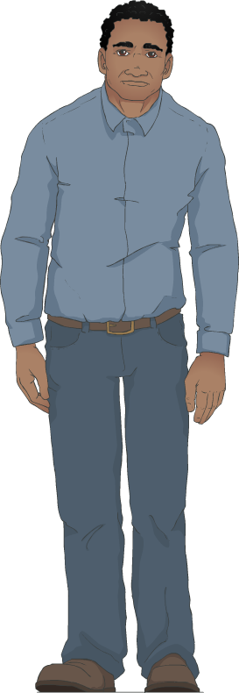

Worksheet Twenty-nine
This worksheet accompanies slide 10 of OMAM_Section_4.ppt

Segregation
Mind-map everything you know about segregation in the 1930s.

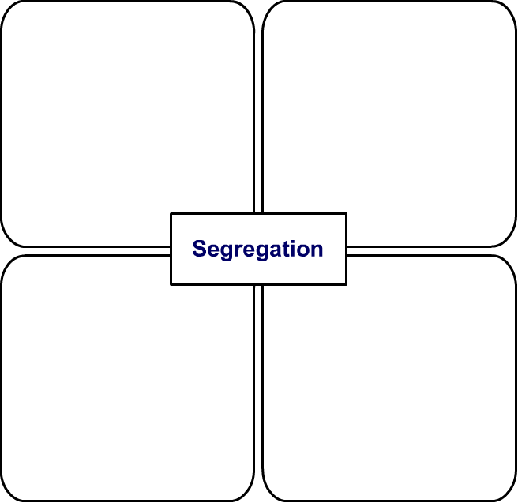
Worksheet Thirty
This worksheet accompanies slide 13 of OMAM_Section_4.ppt

Gender
Mind-map everything you know about how women are represented in the novella.

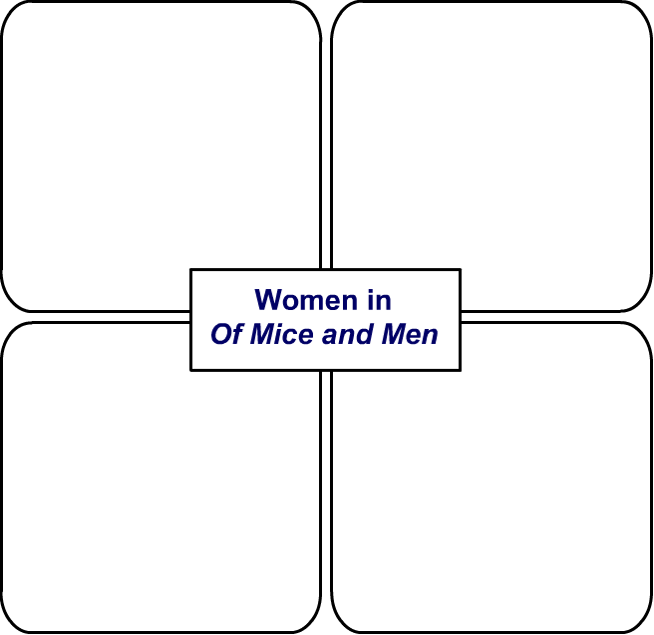

Worksheet Thirty-one
This worksheet accompanies slide 14 of OMAM_Section_4.ppt

Theme: loneliness
Fill in the table below. Add page references so that you can find the quotations again when you need them.

Page | Quotation | Spoken by…
 | “Ever’body out doin’ sum’pin’. Ever’body! An’ what am I doin’?”
 | “Had two brothers. They was always near me, always there.”
 | “Standin’ here talkin’ to a bunch of bindle stiffs… an’ likin’ it because they ain’t nobody else.”
 | “A guy goes nuts if he ain’t got nobody.”
 | “Think I like to stick in that house alla time?”
“Think I don’t like to talk to somebody ever’ once in
a while?”

 | “It’s just the talking. It’s just bein’ with another guy.”
 | “I tell ya a guy gets too lonely an’ he gets sick.”

From OF MICE AND MEN by John Steinbeck, copyright 1937, renewed © 1965 by John Steinbeck. Used by permission of Viking Penguin, a division of Penguin Group (USA) Inc.
Worksheet Thirty-two
This worksheet accompanies slide 17 of OMAM_Section_4.ppt

Marginalization
For each of the following characters, write two or three sentences explaining why they are marginalized and what effect this has on their lives.

Crooks ____________________________________________________________________
_________________________________________________________________________________________________________________________________________________________________________________________________________________________________

Lennie ____________________________________________________________________
_________________________________________________________________________________________________________________________________________________________________________________________________________________________________

Candy _____________________________________________________________________ ____________________________________________________________________________________________________________________________________________________________________________________________________________________________________________________________________________________________________________

Curley’s wife _______________________________________________________________ ____________________________________________________________________________________________________________________________________________________________________________________________________________________________________________________________________________________________________________

