Worksheet Three
This worksheet accompanies slide 3 of OMAM_Section_1.ppt

Plot summary: section one

Complete the summary by filling in the blanks.

Two men called George and _________ make their way down to a clearing beside the __________ River near the town of _________ in _________. They are heading to a nearby __________ to find work. Lennie has a dead __________, which he likes to stroke, in his __________, but George makes him __________ it away. They warm some __________ on a fire for __________ and Lennie asks __________ to tell him about the house and land they are going to__________ one day.

mouse California Lennie throw supper George ranch

beans pocket own Soledad Salinas

Worksheet Four
This worksheet accompanies slide 4 of OMAM_Section_1.ppt

Vocabulary

Match each word to its correct definition.

recumbent
a North American wild dog
sulky and miserable
in a lying down position
a brothel
to think about

contemplate

periscope

anguish

cat house

morose
a submarine observation device

coyote
great distress

Worksheet Five
This worksheet accompanies slide 7 of OMAM_Section_1.ppt, slide 12 of OMAM_Section_3.ppt, slide 16 of OMAM_Section_5.ppt and slide 6 of OMAM_Section_6.ppt

Animal imagery
Animal imagery is often used to describe Lennie. Find some examples from the first section and enter them in the table below. In the column on the left, note the
page reference. In the column in the middle, enter the quotation. In the column on the right, make a brief note of the effect of each image. You will be asked to update this table as you read the novella.

Page | Quotation | Effect
 | XXXXXXXXXXXXXXXXXXXXXX | XXXXXXXXXXXXXXXXXXXXXXX
Worksheet Six
This worksheet accompanies slide 8 of OMAM_Section_1.ppt

George

Mind-map everything you know about George.

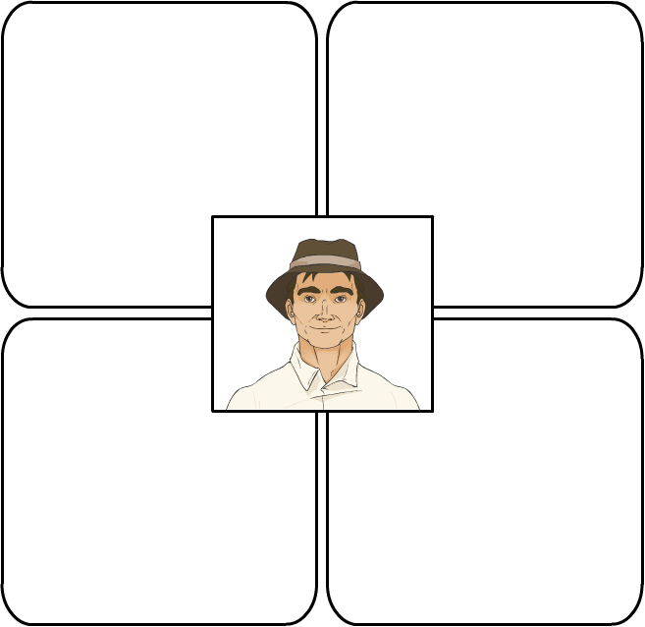

Worksheet Seven
This worksheet accompanies slide 8 of OMAM_Section_1.ppt

Lennie

Mind-map everything you know about Lennie.

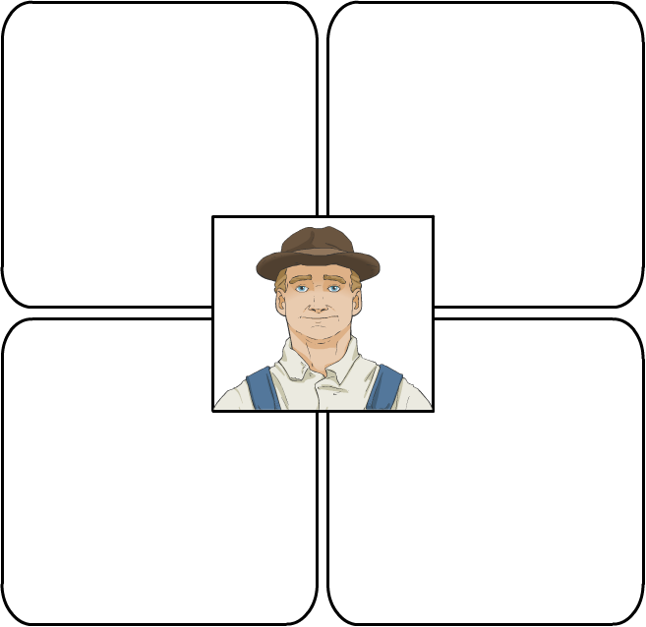

Worksheet Eight
This worksheet accompanies slide 9 of OMAM_Section_1.ppt

Literary devices
The first section of the novella is rich in imagery. Find at least one example of each of the following literary devices:

Simile:______________________________________________________________________________________________________________________________________________________________________________________________________________________________________________________________________

Metaphor:___________________________________________________________________________________________________________________________________________________________________________________________________________________________________________________________________

Onomatopoeia:_____________________________________________________________________________________________________________________________________________________________________________________________________________________________________________________________________________________________

Personification:_____________________________________________________________________________________________________________________________________________________________________________________________________________________________________________________________________________________________

Worksheet Nine
This worksheet accompanies slide 12 of OMAM_Section_1.ppt, slide 14 of OMAM_Section_2.ppt, slide 14 of OMAM_Section_3.ppt, slide 16 of OMAM_Section_4.ppt and slide 8 of OMAM_Section_6.ppt

Predictions
This table is for you to keep a note of possible instances of foreshadowing. In the
first column, enter the page reference. In the second column, enter a quotation that seems to foreshadow some later event in the novella. In the third, write what you predict will happen. When you have read the entire novella, use the fourth column to mark your predictions T or F according to whether or not they came true.

Page | Quotation | Prediction | T/F

